**Awards – Effie Awards, Kam Fan Awards**

Effie Awards

1. Move Effie passage to the right (image 1), consistent to Kam Fan page (Image 2)

**Image 1**

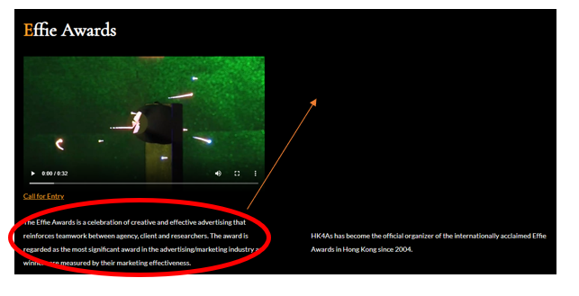

**Image 2**

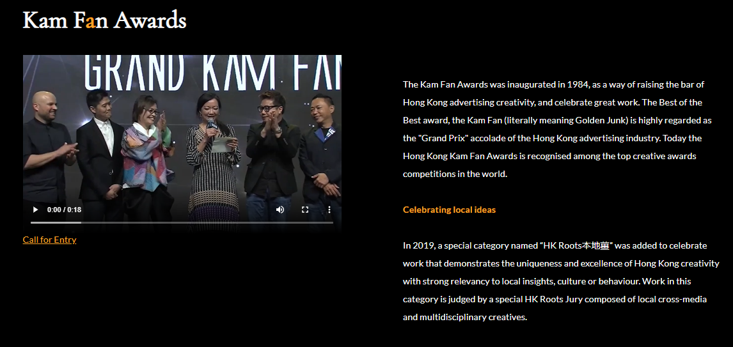

**2. Effie Worldwide Resources**

**-** I created total 3 boxes “Effie Case Database”, “Effie Index” and “Effie Worldwide” with URL links, only find “Effie Worldwide”.

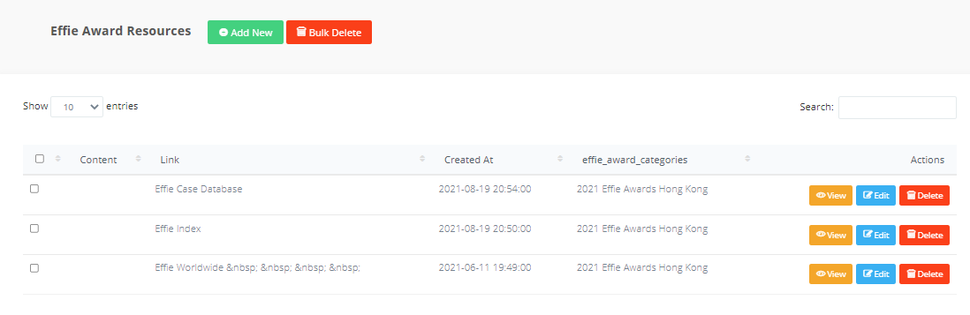

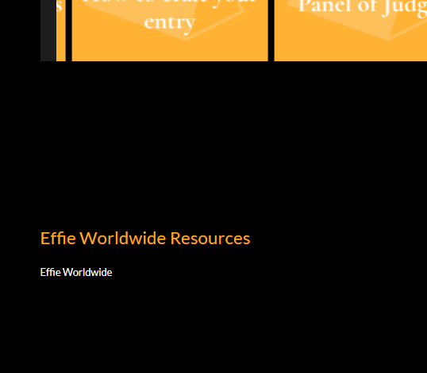

**Awards**

Kam Fan Awards – “Hong Kong Roots”

* A “field” to upload word, pdf files and appears after gallery,

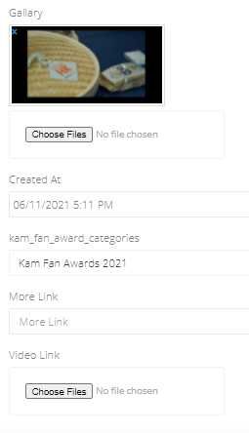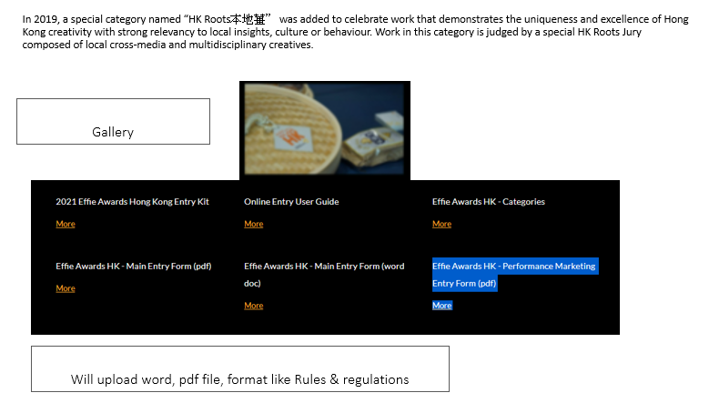

* **Pop up screen again after click onto Kam Fan Awards “call for entry”**

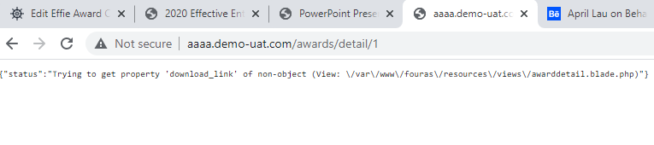

**NextGen**

**Students Award – judges**

* Mobile version looks fine… but desktop one she doesn’t it, the 5th one is in the middle, seems highlighting the odds. Can we single out Chairman on top like image 3 in desktop version.

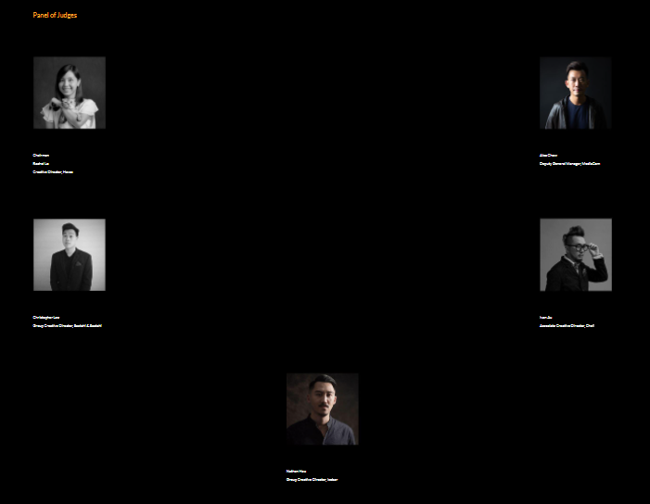

**Image 3**

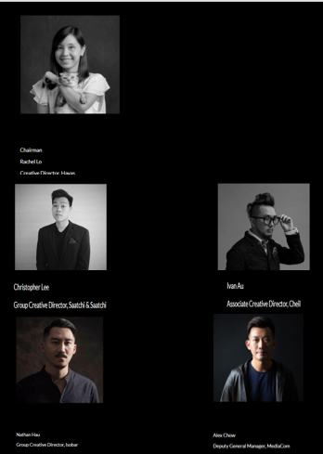

**Questions: it seems after we delete files in Awards pages, it ends up to error message. How to avoid it or what’s the problem behind? Moving forward, what we can do after the website go live?**